**Sustainable Electrical Systems 2016-2017**

**Important notes:**

There were five questions in this exam paper. Students were expected to answer only four of them.

The model solutions are presented in this document. Notes about how the students solved the questions were added during marking where relevant. These *a-posteriori* notes are highlighted in green letters.

**Q1. A question about wind power generation**

a) The graph in Figure Q1.1 shows the power yield of a wind turbine compared against the available kinetic power in the airflow passing through the turbine for a range of wind speeds within the MPPT (maximum power point tracking) operating region. Relevant parameters about the wind turbine can be found in Table Q1.1.

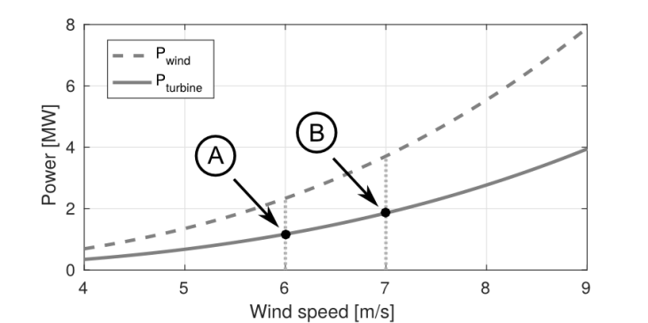  
Figure Q1.1- Power yield and available power from a given wind turbine.

|  |  |  |
| --- | --- | --- |
| **Parameter** | **Value** | **Description** |
| *D* | 150 m | Turbine diameter |
| $$ρ$$ | 1.225 kg/m3 | Density of the air |
| $$P_{turbine}^{rated}$$ | 5 MW | Rated power of the wind turbine |
| $$P_{wind}^{A}$$ | 2.34 MW | Available power at wind speed A |
| $$P_{turbine}^{A}$$ | 1.17 MW | Power yield at wind speed A |
| $$ω_{T}^{A}$$ | 0.72 rad/s | Turbine speed at wind speed A. |

Table Q1.1- Characteristic data wind from a given wind turbine.

Answer the following questions making sure that the procedure you follow is clear in your answer:

i) Calculate the power coefficient, *CP*, of the wind turbine at the operating point A. [1]

ii) Calculate the tip speed ratio, *λ*, at the operating point A. [1]

iii) Calculate the torque of the turbine at the operating point A. [1]

iv) Calculate the torque of the electric generator at the operating point A knowing that the gearbox ratio is 90 if the efficiency of the gearbox is assumed to be 100%. [1]

v) Calculate the turbine speed at the operating point B. [1]

vi) Calculate the capacity factor of the turbine knowing that the annual yield was 17.5 GWh. [1]

b) Answer the following questions regarding the physical principles of wind power conversion:

i) Estimate the maximum power a wind turbine with a blade diameter of 70 m would be able to generate in a site with a wind speed of 9 m/s and an air density of *ρ*=1.225 kg/m3. Make sure that any assumptions you make are very clear. [1]

ii) Explain why the maximum power yield of an ideal actuator disk is obtained when the speed of the airflow downstream is one third (1/3) of the speed of the incoming wind rather than when the speed of the airflow downstream is zero. [2]

c) Answer the following questions regarding wind turbine technologies:

i) List the different modes of operation of a variable speed wind turbine at different wind speeds. Justify the purpose of each mode briefly. [4]

ii) Explain what the pitch mechanism is and how it is used. [4]

iii) Compare the FS-SCIG wind turbine topology against the PMSG wind turbine. Highlight their pros and cons. [3]

**Solution to Q1**

a.i) The power coefficient is the ratio between the power yield of the turbine and the available power at a given wind speed:

$$C_{P}^{A}=\frac{1.17}{2.34}=0.5$$

a.ii) The tip speed ratio is defined as the speed of the tip of the turbine blade divided by the wind speed:

$$λ^{A}=\frac{ω_{T}^{A}R}{v_{w}^{A}}=\frac{54}{6}=9$$

a.iii) The torque of the turbine can be obtained by dividing the turbine power yield by the rotating speed:

$$Γ_{T}^{A}=\frac{P_{turbine}^{A}}{ω_{T}^{A}}=1.63 MNm$$

a.iv) Knowing that the efficiency of the gearbox is 100%, the torque at the output of the gearbox can be calculated as the torque of the turbine divided by the gearbox ratio:

$$Γ_{Gen}^{A}=γ^{-1}Γ_{T}^{A}={90}^{-1}⋅1.63 MNm=18.1 kNm$$

a.v) Both operating points, A and B, are in the MPPT region and it can be seen from the graph that their CP is the same. Therefore, we can assume that the tip speed ratio in both operating points is the same, which implies that:

$$λ=\frac{ω_{T}^{A}R}{v_{w}^{A}}=\frac{ω_{T}^{B}R}{v_{w}^{B}}$$

Therefore:

$$ω_{T}^{B}=ω_{T}^{A}⋅\frac{v_{w}^{B}}{v_{w}^{A}}=0.84 rad/s$$

a.vi) The capacity factor is defined as the ratio between the average power yield of a turbine and the rated power yield of the turbine. The average power yield can be calculated by dividing the energy yield by the number of hours in a year. Therefore:

$$C_{F}=\frac{P_{turbine}^{avg}}{P_{turbine}^{rated}}=\frac{2}{5}=0.4$$

b.i) This question can be solved using the equation of the power yield of a wind turbine, which gives:

$$P_{T}=\frac{1}{2}ρπ\frac{D^{2}}{2}C_{P}v_{w}^{3}$$

If we assume the wind turbine to be an ideal disk actuator operating at the MPP, the power coefficient, *CP*, can be taken as the Betz limit (16/27=0.59), this gives *PT=*1.01 MW. Some candidates may take a more realistic CP instead, for example 0.49, this would give PT=842 kW. Additionally, candidates may also consider subtracting the losses of the drive train and the electrical system, the combination of these two could be estimated as having a 95% efficiency, which would give an electrical power yield of *PE*=800 kW. A right answer with no justification of the assumptions made will be given 0.5 marks.

b.ii) BOOKWORK. At first glance, one may think that a greater reduction of the speed of the airflow may lead to a greater yield; however, the mass flow rate across the actuator disk is not constant and it is reduced when the speed of the airflow downstream is reduced. A greater reduction of the speed leads to more kinetic energy extracted per unit of mass but lesser mass flowing through the actuator disk. Therefore, the optimal operating point is a trade-off between creating a greater reduction of the speed of the airflow without reducing the mass flow rate too much. Note: an informal explanation such as the one above will be given 1 mark, full marks will require the formulation to be used.

The equation of the power yield of an actuator disk as a function of the speed of the airflow upstream, *v1*, and downstream, *v2*, is:

On the other hand, the “available power”, that is, the kinetic power of the airflow crossing the surface of the actuator disk if this didn’t exert any force on the airflow is:

$$P_{0}=\frac{1}{2}ρAv_{1}^{3}$$

The ratio between the extracted power and the available power gives the so-called power coefficient, which indicated how much of the available power is extracted and is the variable to maximise in order to maximise the power yield:

$$C_{P}=\frac{P}{P_{0}}=\frac{1}{2}\left(1-{\left(\frac{v_{2}}{v_{1}}\right)}^{2}\right)\left(1+\frac{v_{2}}{v_{1}}\right)$$

This equation is a third order polynomial and it can be differentiated against *v2/v1* in order to find its stationary points. This gives a maximum of 16/27 ≈ 0.59 for *v2=v1/3*. The value obtained for v2=0 is 0.5, which is lower. Moreover, a downstream speed of zero requires the cross-section of the control volume to be infinite in order for the law of conservation of mass to be respected.

A number of students mentioned that if the speed downstream was 0, a mass of air would build up behind the wind turbine, effectively preventing any air to flow. This idea can be found in many textbooks and it is a bit misleading: according to the ideal actuator disk model, the situation where the speed downstream becomes 0 implies that the cross-section of the control volume downstream is infinite. This makes the mass flow be different than zero and the power coefficient be 0.5 (which is less than 16/27). Arguably this is a limit situation where the soundness of the ideal actuator disk model could be questioned. In any case, the mass flow through the turbine is affected by the speed reduction, which causes a non-monotonous relationship between speed reduction and the power coefficient and this explains the apparent paradox mentioned in this question.

c.i) BOOKWORK. The kinetic energy of an airflow is a function of the cube of its speed; however, the probability of the wind speed in most locations follows a Weibull distribution, which means that wind speeds are more frequent than high wind speeds (see Fig. A1c.i-1). High wind speeds can produce high power yield, however they are rare. Therefore, it is not cost-effective to make wind turbines maximize their yield at high wind speeds. Instead of that, wind turbines are designed to switch to “power reduction mode” when the wind speed is too high. There exist three regions of operation of a variable speed wind turbines which happen at different ranges of wind speed. At wind speeds below the so-called cut-in speed, the generator doesn’t generate any power because losses are greater than the potential yield. At wind speeds above the so-called cut-out speed, the generator remains in a safe stop position as the wind is too strong to keep the wind turbine spinning. In the range between these two speeds there are two different modes of operation: the maximum power point tracking (MPPT) mode and the power reduction mode. The MPPT is used at low wind speeds and the wind turbine is controlled to maximise its yield by using proper torque control of the generator. At power reduction mode, the torque is kept constant and the pitch actuator is used to adjust the power intake to make sure the wind turbine remains spinning at rated speed and the power is kept equal or less than the rated power of the turbine. As a result, a typical variable speed wind turbine characteristic curve looks like the one shown in Fig. A1c.i-2.

Answers including the description of the different modes without a proper justification for them and no plots will be given up to 2 marks. Full marks will require a description with a justification and an approximate plot (unless the shape is well described in the text).

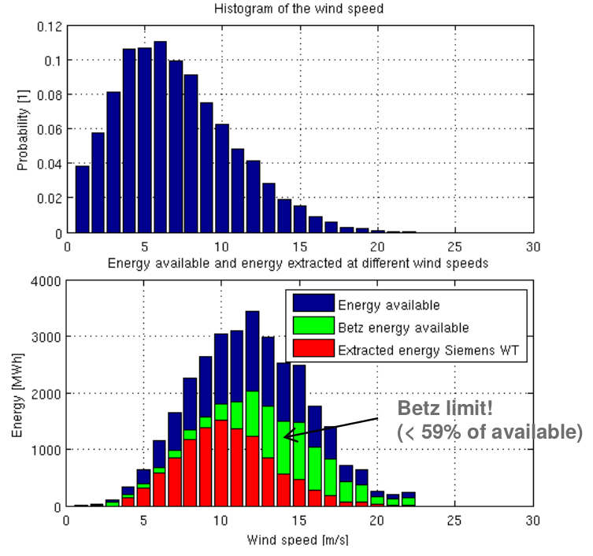

Fig A1c.i-1- Wind speed histogram and energy distribution at different speed ranges.

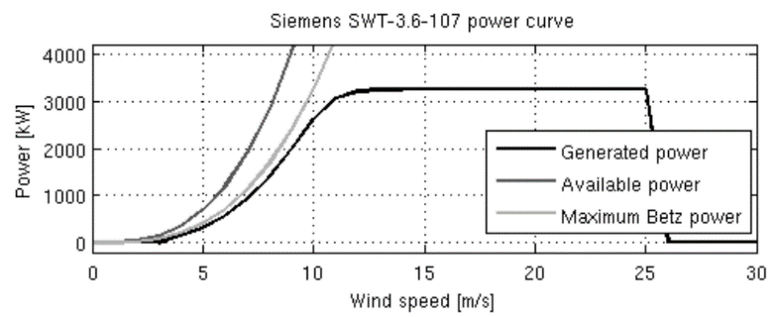

Fig A1c.i-2- Typical characteristic curve of a commercial wind turbine.

Most students explained the different operating modes of the variable speed wind turbine very well; however, a number of students omitted the justification for those operating modes. Full marks were only given to those who justified the need for an MPPT region and a power reduction region caused by the uneven distribution of wind speeds.

c.ii) BOOKWORK. The blade pitch mechanism enables to rotate the blades of the turbine along their axis and control their position. The main purpose of this mechanism is to modify the angle of attack of the profile of the blade, which has a direct effect over the torque the turbine receives from the wind and the power that is extracted from the airflow. This feature is required in order to withstand high wind speeds where the turbine is unable to extract the optimal power and the torque control of the generator isn’t able to reduce the power yield without causing greater mechanical stress over the turbine. The mechanism can be used either when the average wind speed of the site increments slowly over time or when sudden air gusts of short duration occur. There are two main ways to reduce the power using the pitch mechanism, the so-called pitch-to-feather and the pitch-to-stall. The idea of the pitch-to-feather is to decrease the angle of attack of the blade profile in order to reduce the torque. This causes a smooth reduction of the power yield that can be controlled with precision. The main drawback of this procedure is that a great reduction of the yield requires a great displacement of the pitch angle, which may take some time for the pitch actuator to achieve. On the other hand, the pitch-to-stall does the opposite: it increases the angle of attack by rotating the blade in the opposite direction. Rather than causing an increase in the yield of the turbine, it causes a sudden reduction of the pressure on the low pressure side of the blade, causing flow separation and a sudden drop of the lift force. The vortices caused by the flow separation cause vibrations and make precise control in this region be harder to achieve than under normal operation; however, it has the advantage that a small displacement of the blade pitch angle can cause a sudden reduction of the lift.

c.iii) BOOKWORK. The FS-SCIG stands for “fixed-speed squirrel cage induction generator”. In this topology, the wind turbine is coupled to a gearbox which is coupled to an induction generator. The induction generator is connected to the network without any power electronic converter. This means that the wind turbine can only operate at an approximately constant rotating speed, leading to a suboptimal extraction of kinetic energy from the wind at varying wind speeds. Moreover, the machine requires reactive power from the network that must be supplied from external capacitors and care has to be taken when voltage dips occur as the wind turbine may draw high reactive current from the network, which worsens the recovery of the power system. The main advantage of this topology was its simplicity and robustness but the topology doesn’t scale up well to power ratings above the megawatt.

In contrast, the PMSG (permanent magnet synchronous machine) is a topology with a fully-rated power electronic converter where the speed can be controlled at will and the reactive power can be made to be zero or be controlled at will. Moreover, the generator can be designed to be able to operate at low rotating speeds, making it possible to suppress (or at least simplify) the gearbox. The drawback of the topology is that it uses a very uncommon generator that is costly and in the case of the gearbox-less configuration, it is also heavy. Further, the fully-rated power electronic converter can have significant losses, which makes the comparison between the benefits of this configuration against the benefits of the slightly older DFIG still controversial to date.

**Q2. A question about solar photovoltaic (PV) generation**

a) The graph in Figure Q2.1 shows the output current of a PV cell against its output voltage for two different irradiation levels.

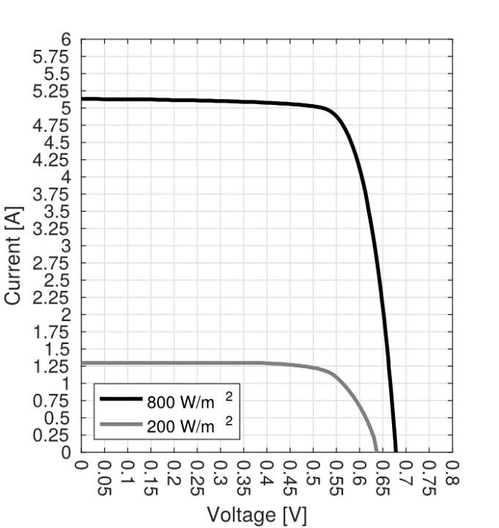  
Figure Q2.1- V-I curves of a solar cell.

Answer the following questions making sure that the procedure you follow is clear in your answer:

i) Sketch the curve of output power against output voltage of the cell and find the approximate coordinates (voltage, current and power) of the maximum power point (MPP) for both irradiation levels. [3]

ii) Calculate the coordinates of the operating point of the cell under an irradiation of 800 W/m2 if a resistor of 0.13Ω was connected to the terminals of the cell. [3]

iii) A PV panel is formed by connecting 96 cells in series. What would the coordinates of the MPP of the panel be if the irradiation of all cells was 800 W/m2? [1]

iv) What would the efficiency of the 96-cell panel be at the MPP for an irradiation of 800 W/m2 if the surface of the PV panel is 1.63 m2? [1]

v) A small PV panel is formed by connecting 2 cells in series. The panel is subject to partial shading (see Figure Q2.2), which makes one of the cells to receive an irradiation of 800 W/m2 while the other cell receives only 200 W/m2. Sketch the approximate V-I curve of the panel under the partial shading condition and find the operating point of both cells if the current of the panel was 1 A. Does the shaded cell generate power under these operating conditions? [3]

  
Figure Q2.2- A 2-cell PV panel subject to partial shading.

b) Answer the following questions regarding the solar energy resource and PV generation technology:

i) What is the meaning of the air mass (AM) number and what does AM0 mean? [2]

ii) Would a mechanical solar tracker be useful in a location where most days are cloudy? Justify your answer. [2]

iii) What happens to the duration of the day and the night at the equinox? [1]

iv) What is the problem of having two strings of series-connected PV cells connected in parallel? How can we mitigate the problem? [3]

v) What is the meaning of the “peak power rating” of a PV panel? [1]

**Solution to Q2**

a.i) The P-V curve can be formed by multiplying voltage by current from the V-I curve. The MPP can be easily identified (see Figure A2a.i).

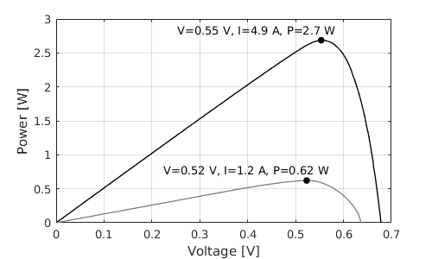  
Figure A2a.i- P-V curve of the solar cell.

a.ii) This question can be solved graphically. The equation that gives the current across the resistor for a given voltage applied across the resistor is: $I=\frac{V}{R}=7.69⋅V$ A/V. This line can be drawn on top of the V-I curve of the PV cell to find the crossing point between the two curves, which will correspond to the operating point of the cell as shown in Figure A2a.ii.

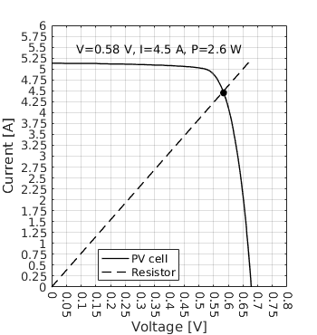

Figure A2a.ii- V-I curve of the PV cell and the resistor.

A number of different solutions were used by different students for this question. Some approximated the constant current and constant voltage regions of the PV cell as straight lines and found an analytical solution for the operating point. Others swept the V/I curve until they found a point where the ratio between voltage and current matched the characteristic of the resistor. Both methods are perfectly valid and were considered to be correct.

a.iii) The MPP for a single cell operating at 800 W/m2 gave a voltage of 0.55 V, a current of 4.9 A and a power yield of 2.7 W. By connecting the cells in series, they are forced to share the same current and their individual voltages add up. Therefore, the MPP of the 96-cell panel would be at 52.8 V, 4.9 A and 259 W

a.iv) The efficiency of the PV panel can be calculated as the power yield of the PV panel divided by the total irradiation over the panel. This gives:

$$η=\frac{259}{800⋅1.63}=19.9 \%$$

a.v) If PV cells are connected in series, their voltages will add up while their current will be the same. The curve of the PV panel can be obtained by “stacking” the curves of the individual cells horizontally (see Figure A2a.v). The operating point of the panel and the individual cells can be found by finding the point of the curves where the current is equal to 1A.

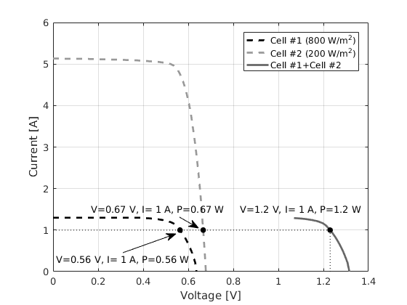

Figure A2a.v.- V-I curve of the 2-cell panel under partial shading.

When a panel is subject to partial shading it may sometimes happen that the voltage across a shaded cell becomes negative; this happens when the current across the panel is higher than the short circuit current of the shaded cell. This causes the cell to draw power rather than to generate it.

The shaded cell in the 2-cell panel is operating below its short circuit current and therefore its yield is positive.

Some students explained the common issues caused by partial shading in series-connected cells but didn’t find the operating point of the cells. The information given in the question was enough to find out the coordinates of the operating point of both cells and therefore full marks were only given to those who found them. Further, some students failed to identify that even though the operating point of the two cells was quite different, they were both generating power.

b.i) BOOKWORK. The air mass number quantifies the thickness of the atmosphere that the sun rays have to cross until they reach the surface of the earth in a specific location. The distance is expressed in relative terms, 1 being the distance a perpendicular sun ray would travel while 0 (AM0) would mean that the light hasn’t crossed the atmosphere. The interaction between the light and the gas and the particles in suspension in the atmosphere has a great effect on the actual irradiation that reaches the surface of the earth, therefore the greater the AM number the greater the effect. The airmass can be approximated as $1/\sin{γ}$ where *γ* is the elevation angle.

Most students explained the meaning of the air mass number very well but a great number of students missed the point that AM0 implies that the rays haven’t crossed the atmosphere, whereas AM1 means that the sun rays are perpendicular to the ground.

b.ii) BOOKWORK. The irradiation received by a PV panel is a combination of the so-called direct irradiation (light travelling in an almost straight line from the sun) and diffuse irradiation (light that is scattered by the particles in the atmosphere and also neighbouring elements on the ground). While maximising the direct irradiation requires proper alignment of the normal of the surface of the PV panel towards the sun, diffuse irradiation is more or less homogeneous in all directions and the orientation of the panel has a weaker effect. A location where the weather tends to be cloudy will have a greater amount of diffuse irradiation; therefore the maximisation of the direct irradiation will be less crucial and will not benefit very much from having a solar tracker.

b.iii) BOOKWORK. The equinox happens twice a year and it corresponds to the times where the sun is in the plane of the equator of the earth. This makes the length of the day and the night to be more or less equal (12 hours) everywhere on earth.

b.iv) BOOKWORK. The parallel connection forces both PV panels to be at the same voltage. If there’s a mismatch between the temperature or the irradiation of the PV panels and the voltage exceeds the open-circuit voltage of one of the panels, the current across that panel will be reversed. If the current across the panel is reversed, the panel will heat up by taking energy from the other panel instead of generating power. This can be prevented by connecting a diode in series with the PV panel before the parallel connection. This diode will incur losses during normal operation but will prevent the current reversal.

b.v) BOOKWORK. PV panels will have different yield depending on their irradiation, their temperature and the load that is connected to them. The peak power rating gives the power that the PV panel will produce at its MPP under standard test conditions. Rather than give an indication of the average power the PV panel will produce, it gives an upper boundary of the power one can expect to obtain from the panel.

Q**3. A question about distributed generation and voltage control**

a) In contrast to the present electricity system that is dominated by conventional generation, a future power system may be characterised by high penetration of renewable and low carbon distributed generation. Answer the following questions:

i) Explain how distributed energy system may achieve higher energy efficiency levels when compared to a large scale centralised one? [3]

ii) Explain why the (present) “fit and forget” approach to distribution network management may limit the amount the amount of Distributed Generators that can be accommodated to the existing networks. [2]

iii) List possible active network management mechanisms and briefly state how these can enhance the ability of the network to accommodate increased capacity of distributed generation. [3]

b) A farm is supplied from a substation through a 3-phase 11kV underground cable of 5 km length which has an impedance of (0.1+j·0.1) Ω/km (see Figure Q3.1). The On-Load Tap Changing (OLTC) transformer is currently set to maintain the voltage at busbar A at 1.03 p.u (+3% of the rated voltage). The farm maximum demand during winter is 5 MW, while the minimum demand during the summer is 1 MW (both with unity power factor). The allowed voltage variation in the 11 kV network is +/- 6%. Answer the questions listed below making sure that the procedure you follow is clear in your answer:

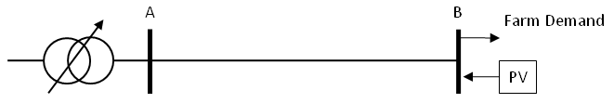

Figure Q3.1- One line diagram of the system in Q3.b.

Answer the following questions regarding a 3-phase PV generation system that will be connected at the farm:

i) What is the maximum amount of PV generation that can be connected at the farm if the power factor of the PV plant is 0.95? [8]

ii) What is the maximum amount of PV generation that can be connected at the farm if the OLTC kept the voltage at busbar A at 1 p.u.? [4]

**Solution to Q3**

Most students were familiar with key active network management mechanisms and were able to explain their working principles.

a.i) BOOKWORK. In the process of generating electricity, significant amount of heat energy is produced that is wasted. The overall thermal efficiency of modern type gas fired technologies (CCGT) is approaching 60%, while the coal-based generation operates at less than 35%. An alternative policy (adopted by some European countries) has been to build smaller power stations nearer to load centres and use these to supply both electricity and heat to consumers (such as district heating) which allows greater use of the available heat and achieves overall efficiency for the supply of heat and electricity loads together of around 80% of the fuel burnt. However heat networks are required for this more distributed system

a.ii) BOOKWORK. Discussion of the following points is needed for full mark: Fit and forget approach will limit the amount of generation than can be connected to the existing distribution networks. These limitations are a consequence of the paradigm of distribution network operation and planning. Constraints on the network would appear in the form of voltage, thermal or fault level constraints violation. Inability to control generation and demand will limit the options for network control and hence limit the amount of generation that may be connected.

a.iii) BOOKWORK. By changing the network operation philosophy from passive to active a number of control options may be used to release the latent network capacity through one of the following:

- Rural areas: generation curtailment, local reactive power compensation, area voltage control, inline voltage regulators to resolve voltage rise effect.

- Urban networks: fault current limiters, to limit the fault contribution from distributed generation and hence avoid replacement of circuit breakers.

b.i) The voltage drop is approximately given by the formula:

$$ΔV≈\frac{R⋅P+X⋅Q}{V}$$

In term of the question, maximum, the voltage at busbar B could be 1.06 and the formula could be written as:

$$ΔV=V_{B}-V_{A}≈\frac{R⋅\left(P_{PV}-P_{Dmin}\right)+X⋅P_{PV}⋅\tan\left(\cos^{-1}{pf_{PV}}\right)}{V_{B}}$$

Therefore:

$$1.06⋅11-1.03⋅11≈\frac{5⋅0.1⋅\left(P_{PV}-1\right)+5⋅0.1⋅P_{PV}⋅\tan\left(\cos^{-1}{0.95}\right)}{1.06⋅11}$$

Solving for *PPV*:

The maximum rating of the PV plant that can be connected at the farm is 6.5MW.

b.ii) Similar to the previous question:

$$P_{PV}≈\frac{\frac{\left(1.06-1\right)⋅11⋅1.06⋅11}{5⋅0.1}+1}{1+\tan\left(\cos^{-1}{0.95}\right)}=12.3MW$$

The maximum rating of the PV plant that can be connected at the farm is 12.3MW.

Some of the students did not correctly apply the procedure for determining the maximum amount of PV generation for the considered 2 cases (b.i and b.ii).

**Q4. A question about security of supply**

a) Answer the following questions:

i) Explain the notion and the reason for capacity margin in a modern power system. How can the optimal amount of capacity margin be determined? [3]

ii) Discuss how the level of redundancy in electricity network design changes with the level of connected load. Explain why there is no network redundancy at LV level in most cases. [4]

iii) Explain why it is important to consider the contribution that non-network technologies can make to network security. [3]

b) A load is supplied from a network plus three distributed generators connected at the same busbar (see Figure Q4.1). Two of the generators have the same characteristics and are denoted as G1, while the third generator is G2. The ratings of generators G1 and G2 are 5MW and 10MW, respectively.The availabilities of generators G1 and G2 are 90% and 80%, respectively. The load is represented by a winter load duration curve with 360 hours at peak (1 p.u.) and the rest of the winter at the off-peak level of 0.6 p.u. (see Figure Q4.1).

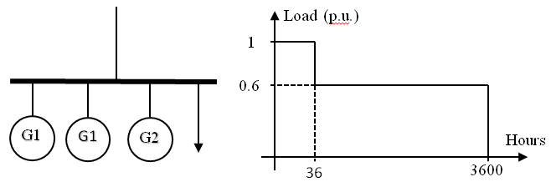

Figure Q4.1- Generator set and load duration curve.

i) Calculate the combined contribution to security of supply of the three generators. [10]

**Solution to Q4**

Students demonstrated strong understanding of the relationship between the level of redundancy in electricity network design and the level of connected load at different voltage levels. In Q4.b most students applied the correct method to calculate for the combined contribution to security of supply of the embedded generators.

a.i) BOOKWORK. The capacity margin represents the magnitude of installed electricity generating capacity above system peak demand. Power system should be planned with a certain capacity margin to ensure that the system’s supply risk is kept at appropriately low levels. The level of capacity margin is determined by balancing the cost of investment in generation and benefits it brings in terms of reducing consequences of outages.

a.ii) BOOKWORK. The level of security in distribution networks is graded and increases with increase in demand level. A simplified illustration of this network design philosophy is presented in Figure above. Small demand groups, less than 1MW peak, are provided with the lowest level of security, and have no redundancy (N-0 security). For demand groups between 1MW and 100 MW, network designs provide n-1 security. For demand groups larger than 100MW, the networks n-2 security. Providing redundancy at 0.4 kV level would significantly increase the cost of network service provision as more than 75% of the entire network cost is in the last mile, and it would not be justified given that amount of load lost would be small.

a.iii) BOOKWORK. Considering security contribution of DG is critical for their competitiveness. Electricity produced by centralised generation is sold in the wholesale market for around 4p/kWh; by the time this electricity reaches the end consumer it is being sold at a retail price of between 10-12p/kWh. This increase in value is driven by the added cost of transmission and distribution services to transport electricity from the point of production to consumption and supplier services. DG however, located close to demand, may be delivering electricity directly to consumers with limited requirement for the use of the network. This power may therefore have a higher value than that of conventional generation (e.g. an equivalent value of between 4-8 p/kWh) due to the potential of DG to reduce the demand for distribution and transmission network capacity and corresponding costs.

Some of the students did not fully understand the approach to determining the optimal amount of capacity margin. In addition, their answers regarding the contributions of non-network technologies (e.g. DG) on network security were not comprehensive enough.

b.i) The peak demand for the calculation of the contribution is equal to the total generators’ capacity i.e. 20 MW. The capacity outage probability table is shown below.

|  |  |  |  |  |
| --- | --- | --- | --- | --- |
| Capacity in service (MW) | Probability | Loss of load: peak load (MW) | Loss of load: off-peak load (MW) | EENS (MWh) |
| 20 | 0.648 | 0 | 0 |  |
| 15 | 0.144 | 5 | 0 | 0.144 x 5 x 360 = 259.2 |
| 10 | 0.17 | 10 | 2 | 0.17 x (10 x 360 + 2 x (3600-360)) = 1713.6 |
| 5 | 0.036 | 15 | 7 | 0.036 x (15 x 360 + 7 x (3600-360)) = 1010.9 |
| 0 | 0.002 | 20 | 20 x 0.6 = 12 | 0.002 x (20 x 360 + 12 x (3600-360)) = 92.16 |

The total EENS is 3075.8 MWh.

The EENS if firm network capacity is 12 MW is

$$\left(20-12\right)⋅360=2880 MWh$$

The capacity of the network (y) to achieve the same level of EENS is

$$\left(12-y\right)⋅3600=3075.8-2880$$

$$y=12-\frac{3075.8-2880}{3600}=11.95 MW$$

Contribution of generators together is 11.95 MW

$$\frac{11.95}{20}=0.597=59.7\%$$

Or in percentage 59.7%.

**Q5. A combined question about demand-side response, hydro power generation and offshore power transmission**

**Demand-side response**

a) Complete the following task:

i) Explain the phenomenon of load payback (or load recovery) that can be encountered when utilising demand-side response (DSR) schemes, and how it may affect the volume of service delivered by DSR. [4]

b) A local distribution grid has a demand profile during peak hours as shown in Figure Q5.1a. The network operator (DNO) has an option to contract with DSR providers that can alter their net demand profile at any given time in line with the profile illustrated in Figure Q5.1b: a load reduction by 25 kW in one hour is followed by a load recovery of 15 kW in the next.

|  |  |
| --- | --- |
| (a) | (b) |

Figure Q5.1- Demand profile of the distribution network (a) and Net demand profile of the DSR (b).

Answer the following questions:

i) Which DSR utilisation strategy should the operator pursue in order to achieve the maximum possible peak reduction if it establishes a contract with **one** DSR provider? [2]

ii) Which DSR utilisation strategy should the operator pursue in order to achieve the maximum possible peak reduction if it establishes contracts with **two** DSR providers? [2]

iii) Find the new peak demand after the use of the DSR in both cases (i and ii above) [2]

**Hydraulic power generation**

c) A micro hydraulic generation system consists of an upper water reservoir that feeds a penstock that goes to a turbine that generates power (see Figure Q5.2). The characteristics of the system and its operating point are summarised in Table Q5.1.

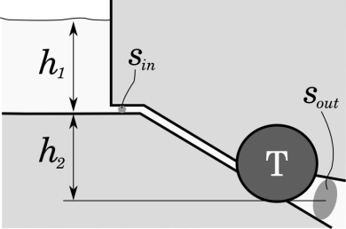

Figure Q5.2- Diagram of the dam.

|  |  |  |
| --- | --- | --- |
| **Parameter** | **Value** | **Description** |
| $$h_{1}$$ | 5 m | Water depth upper reservoir. |
| $$h_{2}$$ | 15 m | Height penstock |
|  | 0.01 m2 | Cross-section of the inlet |
|  | 0.03 m2 | Cross-section of the outlet |
|  | 1,000 kg/m3 | Density of water |
| $$\dot{m}$$ | 5 kg/s | Mass flow |

Table Q5.1-Characteristic parameters of the micro-hydro system

Complete the following tasks

i) Calculate the speed of the water at the intake (where *Sin*) and at the output of the turbine (where *Sout*). [2]

ii) Calculate the gauge pressure (the difference with the atmospheric pressure) at the water intake (where *Sin*). [1]

iii) Calculate the power yield of the turbine if we know that the gauge pressure at the output (where *Sout*) is 98 kPa. [2]

**Offshore power transmission**

d) Answer the following questions regarding transmission technologies:

i) Why is the transmission distance that can be reached using HVAC with cables much shorter than the distances that can be reached using overhead lines? [2]

ii) Enumerate the potential benefits of multi-terminal HVDC when compared to point-to-point HVDC- [1]

iii) Enumerate the advantages of XLPE-insulated HVDC cable when compared to MI-insulated cable. [2]

**Solution to Q5**

**Demand-side response**

Most of the students calculated correctly the modified system demand profile after executing different DSR utilization strategies.

a.i) BOOKWORK. The application of DSR schemes tends to disturb the natural diversity of loads. DSR applications rely on the ability of controlled devices (appliances) to reschedule operation (production) or the ability to continue operating during the interruptions by drawing on some form of storage (thermal, chemical or mechanical energy or intermediate products). DSR therefore redistributes the load but does not necessarily reduce the total energy consumed by the device or appliance. Load reduction periods will be followed or preceded by load recovery, the duration of which will depend on the interrupted process and the nature of the storage. This affects the volume of service (e.g. peak reduction) delivered by DSR providers, as the demand during recovery period generally increases compared to before the intervention, and can potentially exceed the original peak demand that DSR was trying to minimise.

Reducing demand from thermostatically controlled loads generally results in energy payback as a consequence of the physics of heat transfer from the building or appliance to the surrounding space and vice versa combined with the objective to follow the target temperature profile. For instance, if the cooling of a building is reduced during e.g. 1-hour period, the indoor temperature will increase and once the reduction period expires the building temperature control will attempt to bring the temperature back to the pre-reduction level as soon as possible. Bringing the temperature down within a short time frame will require more energy than just maintaining the temperature at a constant level, and this will partially offset the energy reduction effected during the 1-hour control interval.

Some of the students did not understand the importance of the concept of load payback effect, and therefore were unable to explain how this affected the volume of service delivered by DSR.

b.i-iii) The following represent the optimal DSR utilisation strategies and resulting demand profiles:

|  |  |  |
| --- | --- | --- |
| i) |  | Optimal DSR utilisation:  at 6pm  *Pmax* = 240 kW |
| ii) |  | Optimal DSR utilisation:  at 6pm  at 7pm  *Pmax* = 225 kW |
|  |  |  |

**Hydraulic power generation**

c.i) The volumetric flow can be calculated as the cross-section of the pipe multiplied by the speed. The mass flow rate and the cross-section of the penstock and the discharge of the turbine are known; therefore, the speed of the water can be calculated as:

$$v_{in}=\frac{\dot{m}}{{ρ⋅S}_{in}}=0.5 m/s$$

$$v_{out}=\frac{\dot{m}}{{ρ⋅S}_{out}}=0.17 m/s$$

c.ii) The pressure at the intake can be calculated using Bernoulli’s equation of conservation of energy between the free surface of the water in the upper reservoir and the intake of the penstock:

$$h_{1}=\frac{p_{1}}{ρ⋅g}+\frac{v_{in}^{2}}{2g}$$

Therefore $p_{1}=h_{1}⋅ρ⋅g-\frac{{ρ⋅v}_{in}^{2}}{2}=48.9 kPa$

c.iii) The power extracted by the turbine can be found as the difference between the energy of the water in *Sin* and the energy in *Sout*.

**Offshore power transmission**

d.i) BOOKWORK. The greatest difference between the overhead lines and the underground cables for long distance HVAC transmission is the stray capacitance of the conductors. The reactive current that is generated by the stray capacitance wastes part of the current rating of the conductor that is meant to transfer active power. The problem become worse the longer the conductor is and it is more pronounced in cables than in overhead lines. Conductors in overhead lines are far from each other and far from the ground whereas the distance between the phase conductors and the ground (or the grounded protective sheath of the cable) is very small. Losses and required conductor section are normally reduced in HVAC by increasing the voltage (and therefore decreasing the required current); however, higher voltages make the problem of the stray capacitance worse. Therefore, the use of cables for HVAC transmission is limited to relatively short distances and relatively low voltages.

Most students correctly stated that long cables had large stray capacitance, leading to high reactive current that undermined the ability to export real power but a few students implied that conductors overhead lines didn’t have any stray capacitance. This is not true: overhead lines have less stray capacitance, which makes the stray current become an issue at much greater distances than it does in cables. A few other students mentioned heating losses due to shunt conductance and series resistance as the problem with cables. However, these are minor issues compared to the problem with capacitance.

d.ii) BOOKWORK. A multi-terminal HVDC is a system where multiple AC/DC converter stations are connected together to form a DC transmission grid. The benefits for a meshed grid topology are similar to those that favour meshed HVAC transmission grids. This can be summarised as:

- Greater flexibility to adapt the power flows across long distances at different times to accommodate different patterns of generation and demand.

- Better redundancy and availability: while a loss of one converter station means the loss of the entire transmission link in point to point HVDC, a multi-terminal HVDC can in some cases keep operating without one of the stations.

- Better utilisation: with greater flexibility to adjust the power flow, it becomes possible to optimise the use of the assets. For example, an offshore wind farm connected to two separate mainland systems can sell the energy to one of them (instead of curtailing generation) if the other system can’t take the infeed.

d.iii) BOOKWORK. XLPE insulation has several advantages when compared to MI. Namely: the insulation material is easier to manufacturer, which makes the cost per unit of length to be lower. The XLPE cable is also thinner and lighter for the same level of insulation and mechanical strength; therefore, the bend radius of the cable is smaller and a greater length of cable can be carried in a ship, which speeds up the deployment of the cable. The process of creating joints in XLPE is also significantly quicker than it is with MI, which speeds up the installation of the cable and lowers the cost of building the transmission links.